**COMMUNICATIONS SUBSECTION FOR THE CUBESAT ‘SPIRIT’**

by

Daniel Rea

Rajja Singh

Zhengxing Liu

Jiayang Song

(advisor: Dr. Jayshri Sabarinathan)

ECE4416 Electrical Engineering Design Project

**Progress Report**

**Department of Electrical and Computer Engineering**

Western University

London, Ontario, Canada

**Date**

# **1. Introduction/Background**

## **1.1 Problem Statement**

The CubeSat project at Western University aims to help Western Engineering students gain valuable experience in the space domain, working alongside experts in the field including personnel from the Canadian Space Agency to develop a CubeSat. The Spirit Communication team is working to develop a system that uses S-Band frequencies to allow communication between the CubeSat and the ground station. The main objective of the CubeSat is to send pictures and 3600 immersive videos to the ground station.

## **1.2 Detailed Literature Review**

**Reasons for Using S-Band**

Since 2003, there has been a drastic increase in the popularity of CubeSats, as they provide university students with attainable project experience to enter the space sector. Currently, 2140 picosatellites have been launched, and it is speculated that 3000 more will be launched in the next 6 years [1]. With so many CubeSats in orbit, the amateur radio frequencies (100-500 MHz range) where most of these CubeSats operate is becoming cluttered. A predominant solution to this problem is in using the less cluttered higher frequency bands such as S-Band, C-Band, or K-Band [1]. The size of the ground antenna used to radiate the signal to free space is proportional to its signal wavelength given by the equation:

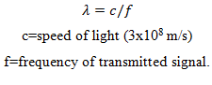

This means that using higher frequencies also reduces the size of the ground station antenna [2]. These are the reasons why CubeSat 'Spirit' will operate in S-Band (2-4Ghz).

**Required Components for a Successful Communication system**

After review of numerous launched CubeSats in [3], it was determined that any successful communication subsystems contain 3 components. These are namely transmitting antenna, receiving antenna, and transceiver. Building a transceiver from scratch is ill advised for beginner CubeSat programs since RF board design is difficult and margin for error is great [4]. It is thus recommended that Spirit use customer off the shelf components for antennas and transceiver [4]. Component selection for an efficient communication system will rely on careful consideration of key restricting factors.

**Key Restrictions Overview**

When it comes to any wireless communication systems, there are two main restrictions that a designer must prioritize: Power Efficiency and Spectral efficiency [2]. For CubeSat specific design, there are many more secondary restrictions related to other subsystems. Power and Spectral efficiency will be discussed below, while the rest will be presented in Project Objectives.

" Power efficiency relates to the ability to transmit data with a given bit/symbol error probability at a minimum received power level. The received power is usually measured in terms of the Signal to Noise Ratio (SNR), which is ratio of the received energy per bit (𝐸𝑏) and the noise power spectral density (𝑁𝑜). SNR is usually expressed as 𝐸𝑏/𝑁” [5] In a CubeSat, the transceiver is the component that consumes the most DC power [2]. This implies that the power efficiency of the entire CubeSat depends heavily on proper transceiver selection. Basic Energy Efficiency of a transceiver can be defined as its power efficiency over a time period T; given by the equation:

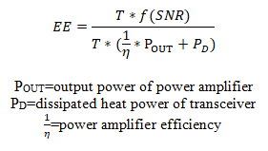

Energy efficiency can be maximized by either increasing the numerator or decreasing the denominator. Increase of the numerator implies an increase in transmission rate, which involves the entire system including a transceiver, antennas and channel condition [3]. It follows that a proper modulation scheme aboard the transceiver must be selected to optimize SNR and thus transmission rate.

Spectral [or 'Bandwidth] efficiency refers to rate of maximum information being transmitted over a given bandwidth in a specific communication system [2], and is given by the equation:

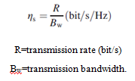

Transmission bandwidth (Bw) will be provided by the Canadian Space Agency (CSA). Thus, transmission rate R must be maximized in order to optimize spectral efficiency. Data transfer is directly proportional to power supplied, but on a 2U CubeSat, power is extremely limited. It follows that one of the most appropriate ways for maximizing the data rate of a CubeSat is to use efficient modulation schemes [3].

In conclusion proper modulation and coding contributes heavily to the power efficiency and spectral efficiency of the transceiver. Regardless of whether a designer chooses to value one over the other, it is important to realize that there is always a tradeoff between the two [5]. For example, Error correction coding typically increases power efficiency of transmission at the cost of bandwidth efficiency. A trade-off study of different modulation techniques as well as different antenna configurations to follow in the concept generation and evaluation portion of this report.

## **1.3 Project Objectives**

The objective for the CubeSat project is to design and do preliminary prototyping for a 2U CubeSat operating in the S Band. The CubeSat will store virtual reality images and videos of the Earth. The communication subsystem’s main objective is to transmit as much of the data stored onboard the CubeSat to the ground station. To accomplish this goal, we will need to coordinate with the ground station team. We will need to design the antenna and transceiver circuit on the CubeSat that will use a 2-2.4GHz frequency to transmit and receive data from the satellite to the ground station. The modulation scheme and encoding technique that is used for data transmission from the CubeSat will need to be coordinated with the onboard computer and ground station teams to make sure they can receive and read the data that we will transmit from the CubeSat.

With minimal resources and space available on the CubeSat there were several constraints that had to be met. The antenna mass was limited to 100g and the transceiver mass was to be kept below 200g to make sure that the center of gravity was maintained while keeping the total mass of the CubeSat below 3.6kg. The power consumption was limited to 6W for transmission mode and 1W for standby mode.

The CubeSat communication system is composed primarily of the telemetry and command systems, which send and receive data, respectively. Analog and digital data collected by the sensors and payload of the satellite must be relayed to the ground station via the telemetry system, which is composed of a transmitter that acts much like a “modem in a computer”. The transmitter then sends the signal to the ground station through the satellite’s antenna. A radio operating in the S-band at the ground station will receive the data signal and encode the stream to a form that may be interpreted by software on a laptop.

# **2. Design Approach**

## **2.1 Concept Generation**

**Antenna**

To generate and select antenna options, a list of requirements is made to highlight the desired features and constraints of the antenna.

1. Antenna must operate in the S-band frequency range of 2.2 - 2.5GHz
2. Antenna shall provide enough gain to achieve desired data rate
3. Antenna may be deployable, but it must fit within PPOD for launch
4. Antenna shall avoid obstructing the view from the camera if possible

After reviewing the requirements, the patch antenna and dipole antenna are chosen for further evaluation. These two designs are the most commonly used antennas for satellite communication. They will be evaluated based on their gain, directivity, their mounting mechanism and placement.

**Option 1. Patch antenna**

The Patch Antenna is a flat sheet of metal that would be mounted on the surface of CubeSat. It is more directional thus it needs to be facing towards the earth for transmission. It requires active pointing mechanism, so it puts more demand on the attitude control subsystem. By sacrificing the beam width coverage, the patch antenna has a higher antenna gain. More power can be transmitted, hence more data can be downloaded. The patch antenna also needs to be mounted on the entire z-plane, which forces the cameras be to be placed on the sides. It results an obstruction in the view of the camera, then the desired 360° view of space is unachievable.

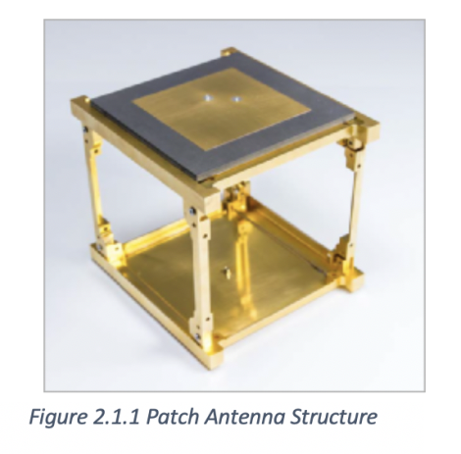

**Option 2. Dipole antenna**

The dipole antenna is simply a piece of conducting wire. In this case, there will be four dipole antennas forming an antenna array. Dipole antenna is a simpler antenna, so it would be easier to model and implement. Its radiation pattern is toroidal in shape and omni-directional in the azimuth plane. Due to its broader coverage, only passive attitude control is needed. The CubeSat would be tumbling freely in space, yet the antenna can still transmit to ground station. However, it also means the dipole antenna has less gain, less data can be transmitted. Since the dipole antenna can be mounted on the rails, it makes room for the cameras to be mounted on the z-planes, shooting the full unobstructed 360° view.

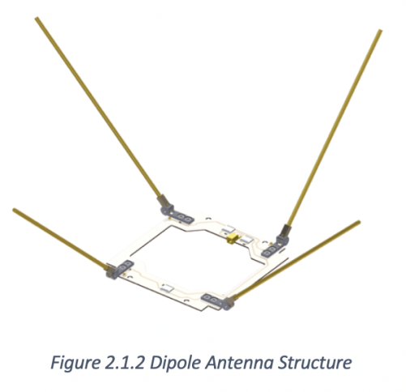

**Transceiver**

When it came to concept generation for transceiver options, the following requirements were considered:

1. Transceiver must send and receive data in the s-band frequency range
2. Transceiver must be less than 200g and consume less than 6 watt in transmitting mode
3. Data rate of board shall be maximised while maintaining all other requirements
4. A proper modulation scheme shall be selected to place even focus on power and spectral efficiency

Since an off the shelf transceiver will be purchased, the first two requirements immediately canceled out many options. What remained for selection were transceivers with various data rates and modulation schemes. Control over the modulation scheme is limited to what the transceiver is stocked with. However, a trade-off study between different modulation techniques provided the designer with a range of acceptable techniques in a transceiver that would suit project objectives.

**Modulation Trade-Off study**

Different modulation schemes place focus on one of the two key restrictions of power efficiency and spectral efficiency. For example, higher order modulation schemes pack the transmitting signal with more bits per symbol, allowing for higher data rates [7]. However, this implies that more power must be used to send error free data. Alternatively, a spectrally inefficient modulation scheme combined with error correction coding could maintain the same throughout as mentioned before, but would require more bandwidth [7]. The figure below shows the bit error rate (BER) performance of different order modulation schemes at varying normalized SNR levels.

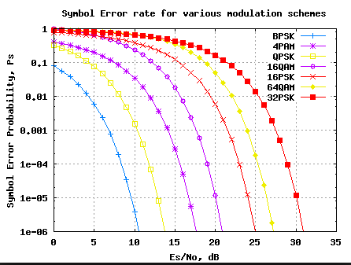

Figure: Symbol Error rate for various Modulation Schemes

As expected, 64QAM relative to 16QAM requires more power, but will make efficient use of allotted bandwidth due to more tightly packed symbols. Higher order techniques such as 8-QAM, 16 QAM and 32-QAM provide higher SNR and thus, more throughput. However, these techniques require greater size and more power. Considering that the Electrical Power Subsystem provide a maximum of 6 watts, all modulation orders of 16 or higher are deemed unacceptable due to unattainable power requirements.

As per [8], two previous CubeSats used 2-FSK as their modulation scheme since their mission only required transmitting telemetry data. For Spirits case, a VR camera taking high resolution video will add immensely to required transmitted data on top of the telemetry. For this reason, all binary modulation schemes are deemed unacceptable due to low throughput.

In conclusion, A modulation scheme with a moderate number of constellation points is required. This will ensure that the communication subsystem has a high enough data rate while remaining within the bandwidth and power limitations. Particular schemes for consideration were OPSK, OQPSK, MSK and GMSK due to their superior performance in terms of BER and relatively equal emphasis on bandwidth and power efficiency.

**2.2 Concept Evaluation and Selection**

**Antenna Evaluation**

The antennas are modelled in MATLAB using the antenna toolbox, the follow graphs illustrate the antenna radiation patterns.

**Option 1. Patch Antenna**

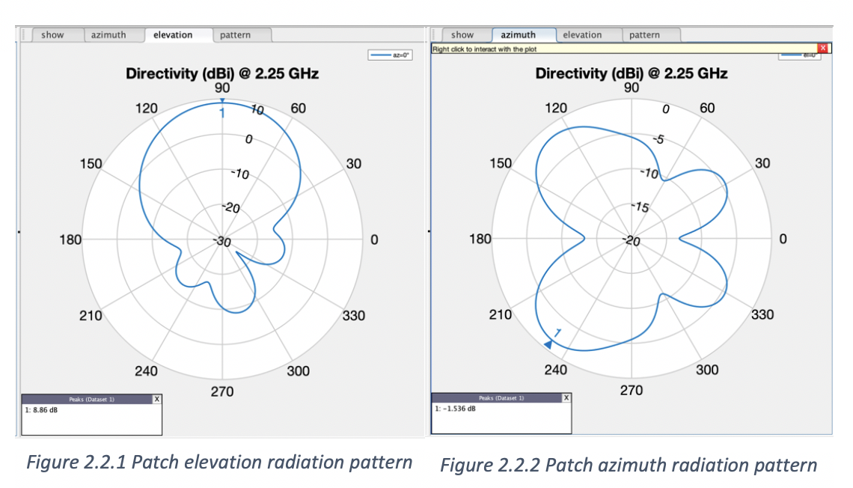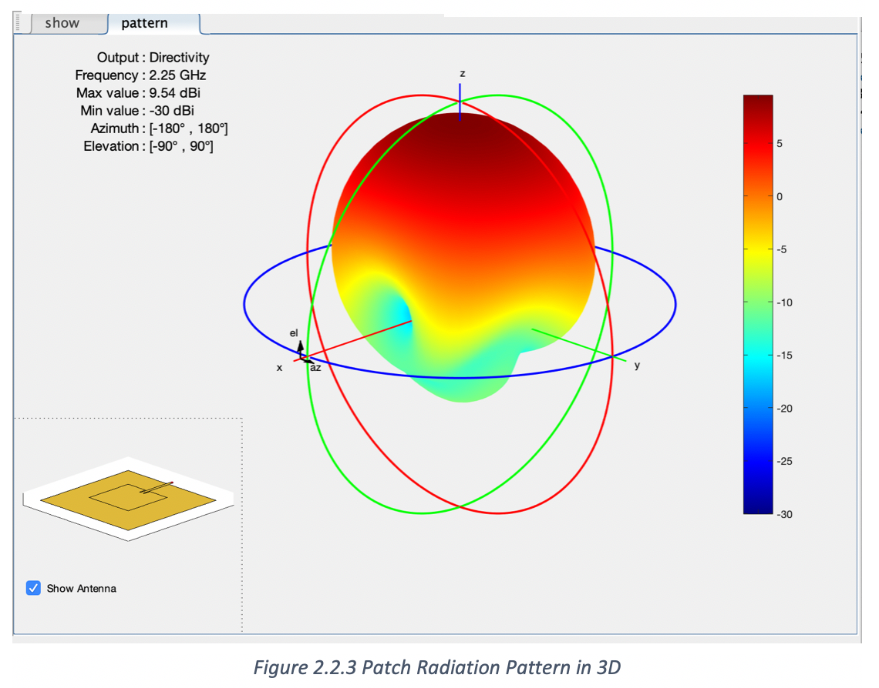

**Option 2. Dipole Antenna**

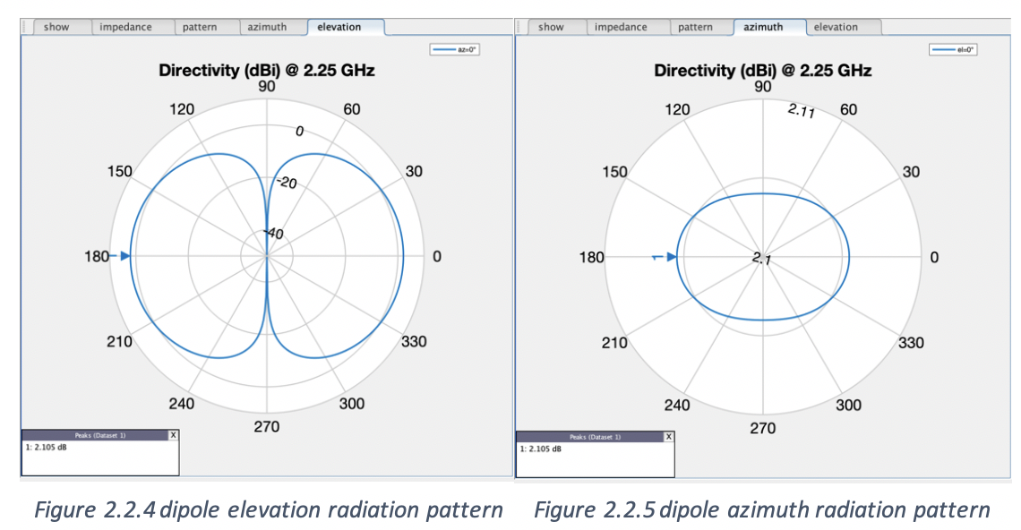

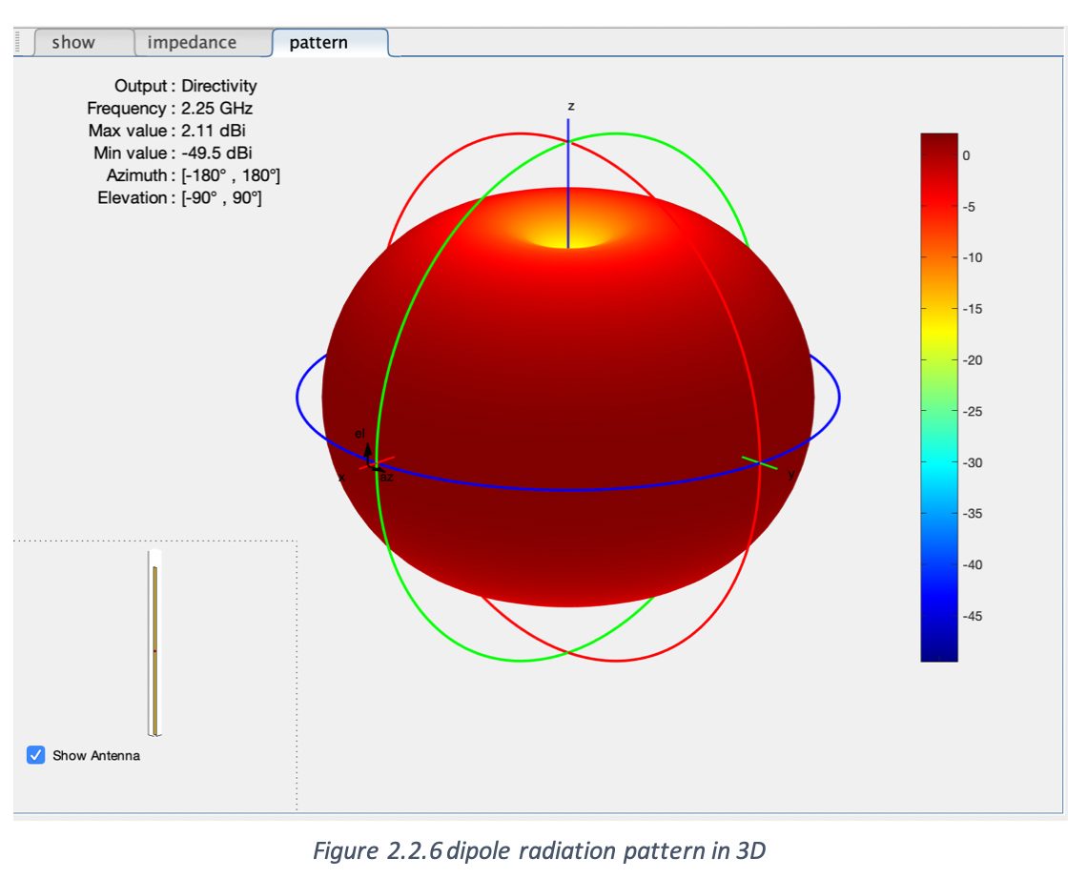

## Graphically, the patch antenna is more directive than dipole antenna. In the elevation plane, the radiation pattern of the patch antenna creates a distinct separation between the main lobe and side lobes. The antenna steers upwards towards the z-plane with a beam width of 59˚. Because it is more directed to one point, the patch antenna can reach a high maximum gain at 9.53dBi.

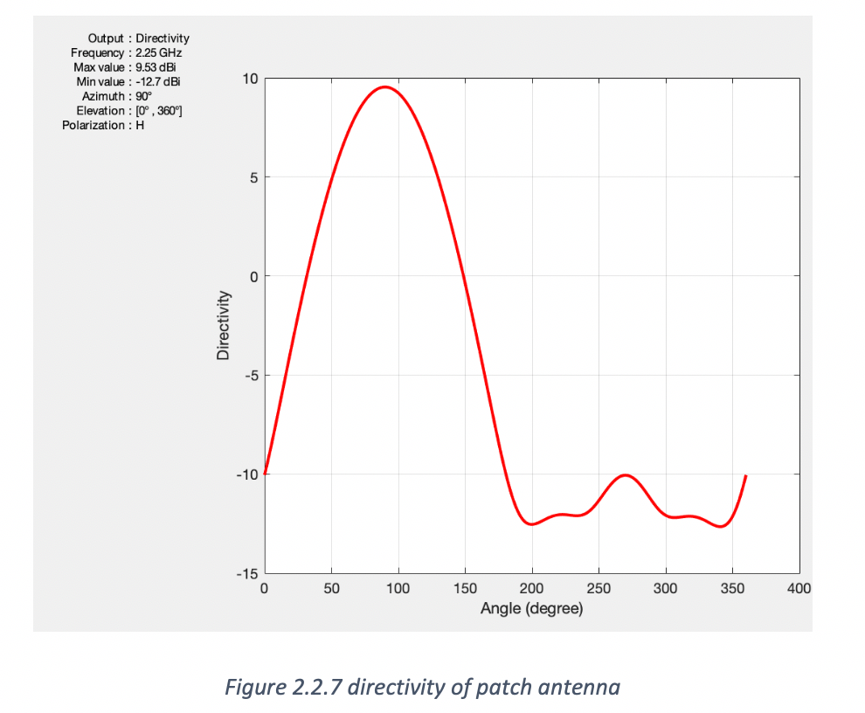

## For the dipole antenna, the radiation is appearing more like a sphere radiating outwards, it’s omni-direction in azimuth plane and toroidal in elevation plane. The beam width of the dipole antenna is 80˚. With less directivity, the maximum gain of dipole antenna can only reach 2.11 dBi.

## Since we are designing the transmission link in S-band, the main objective is to achieve a faster data rate at the 2.4GHz frequency rather than the traditional UHF frequency band; therefore, patch antenna is the better option.

## **3. Preliminary Analysis**

## **3.1 Engineering Techniques/Software Tools**

**MATLAB Antenna Toolbox**

The antenna toolbox is an add-on module in MATLAB which provides simulations and analysis for designing antennas. It computes properties such as impedance, charge distribution and field properties for antenna design. It also provides 3D visualization for the radiation patterns and antenna geometries.

For the purpose of our CubeSat Design, the antenna toolbox is used to determine the radiation pattern for various types of antennas. Models of the antennas are built in the module to generate the 2D (azimuth and elevation) and 3D figures of the radiation patterns. Visual figures help to analyze the antenna gain, beam width and directivity, which are used to evaluation antenna design options. Detailed analysis created by the antenna toolbox is listed in section 2.2.

**Excel**

Excel is the main software used for link budget calculation. The data rate calculation is divided into seven sections: data rate, modulation specification, modulation scheme comparison, Noise temperature, receiver antenna, transmitter antenna and beamwidth. Some of the data in the excel are constants or given from the device specifications, and the rest of them are computed by equations. The modulation scheme part shows the difference between various digital modulation schemes and we pick the best out of them. The noise temperature part applies a common model for the receiver system and calculated the theoretical system thermal noise temperature. This parameter is important in the later section to compute the signal noise ratio (SNR). The coefficients in receiver and transmitter sections are derived from datasheets of hardware. Combing the sections above we can get the theoretical data rate which is supported by the antennas and communication channel.

## **3.2 Preliminary Analysis**

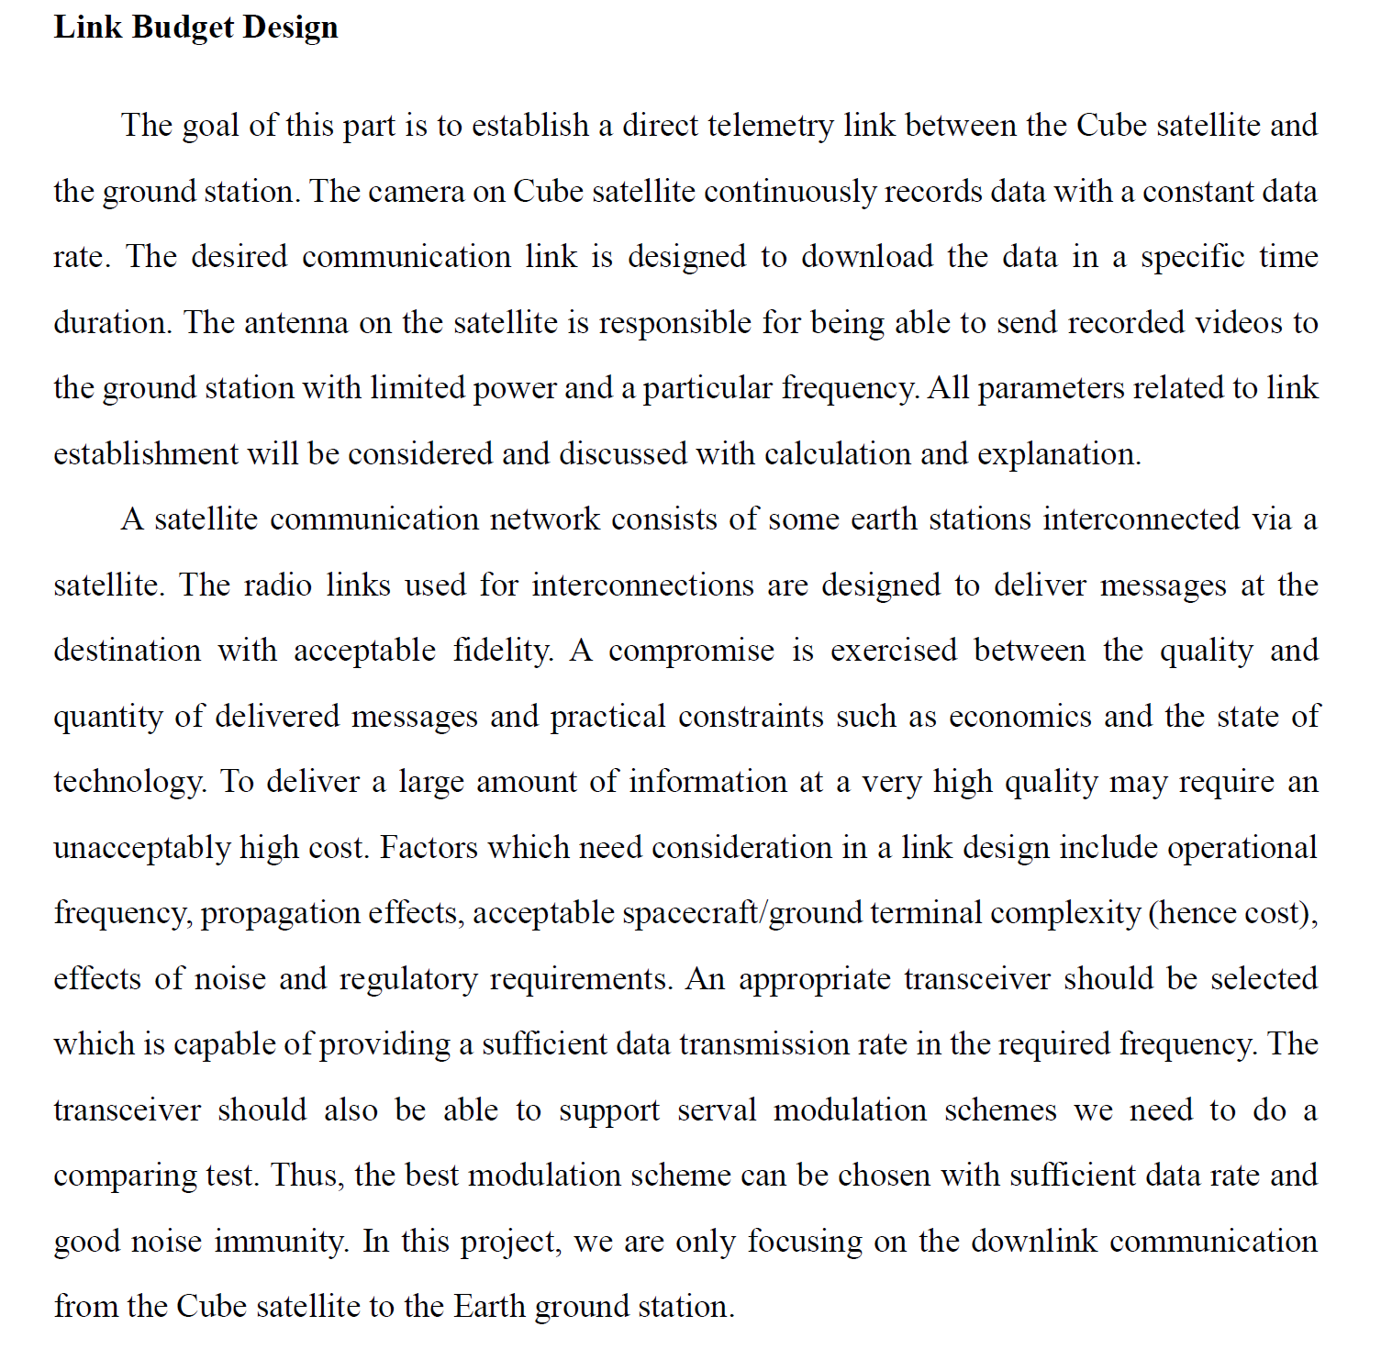

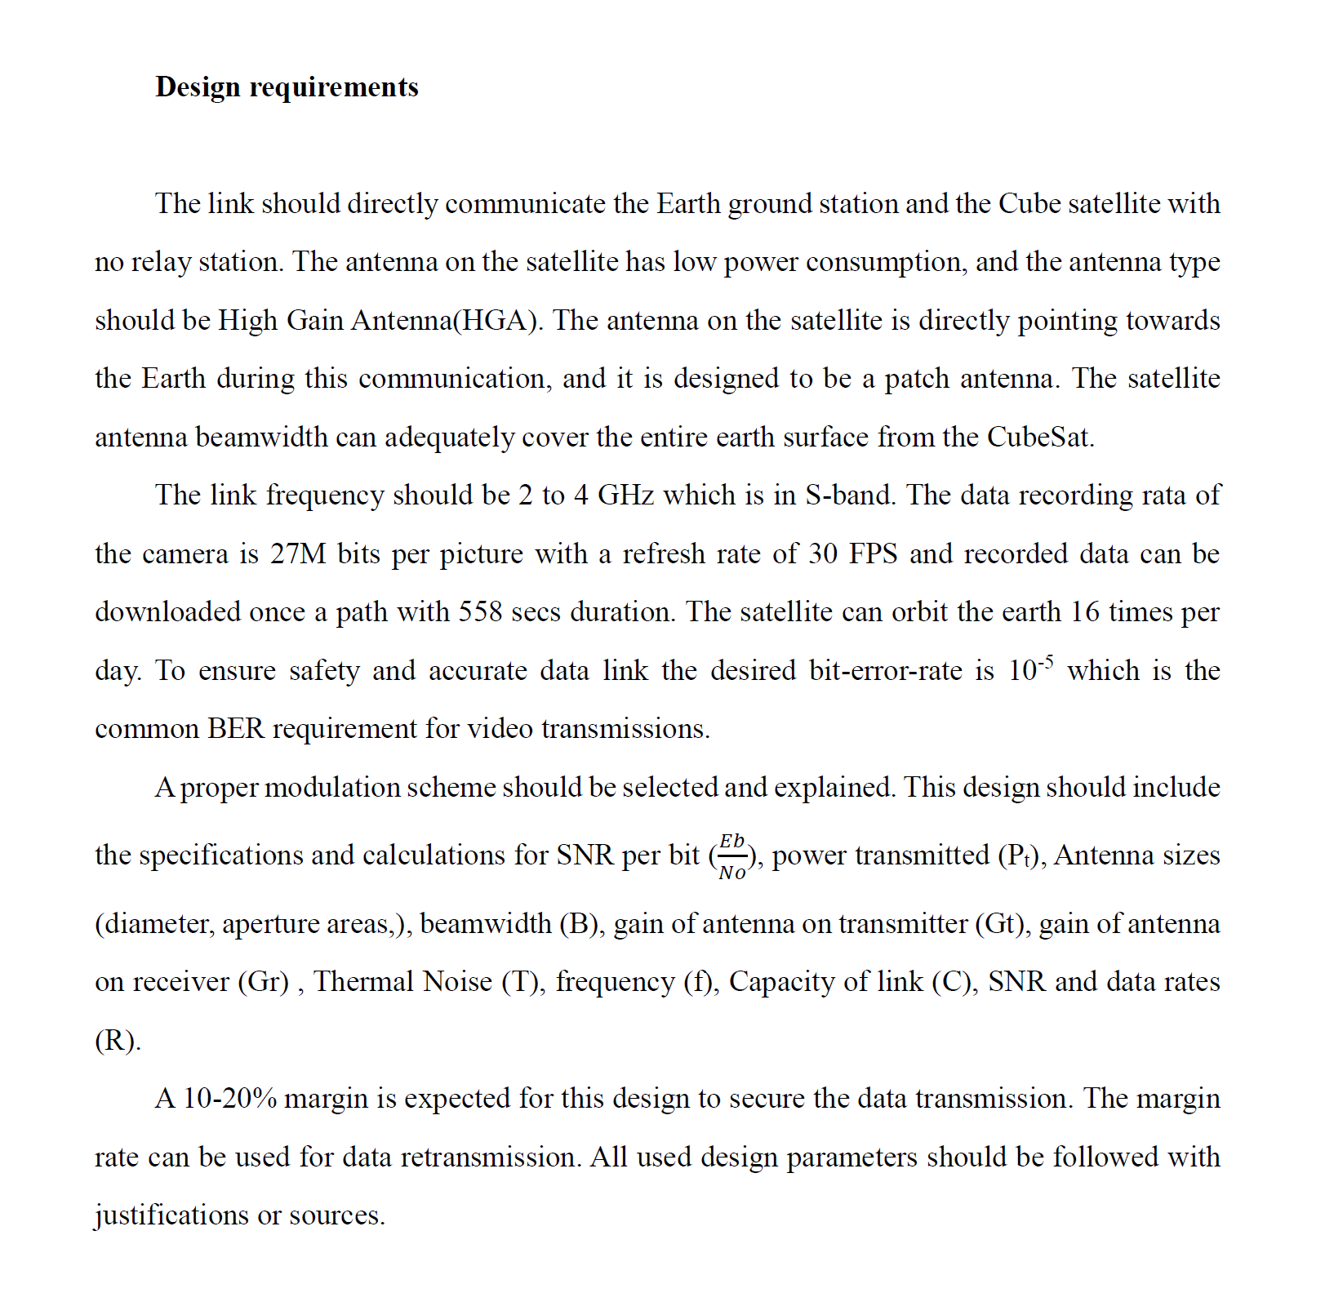

**Data Rate Calculation**

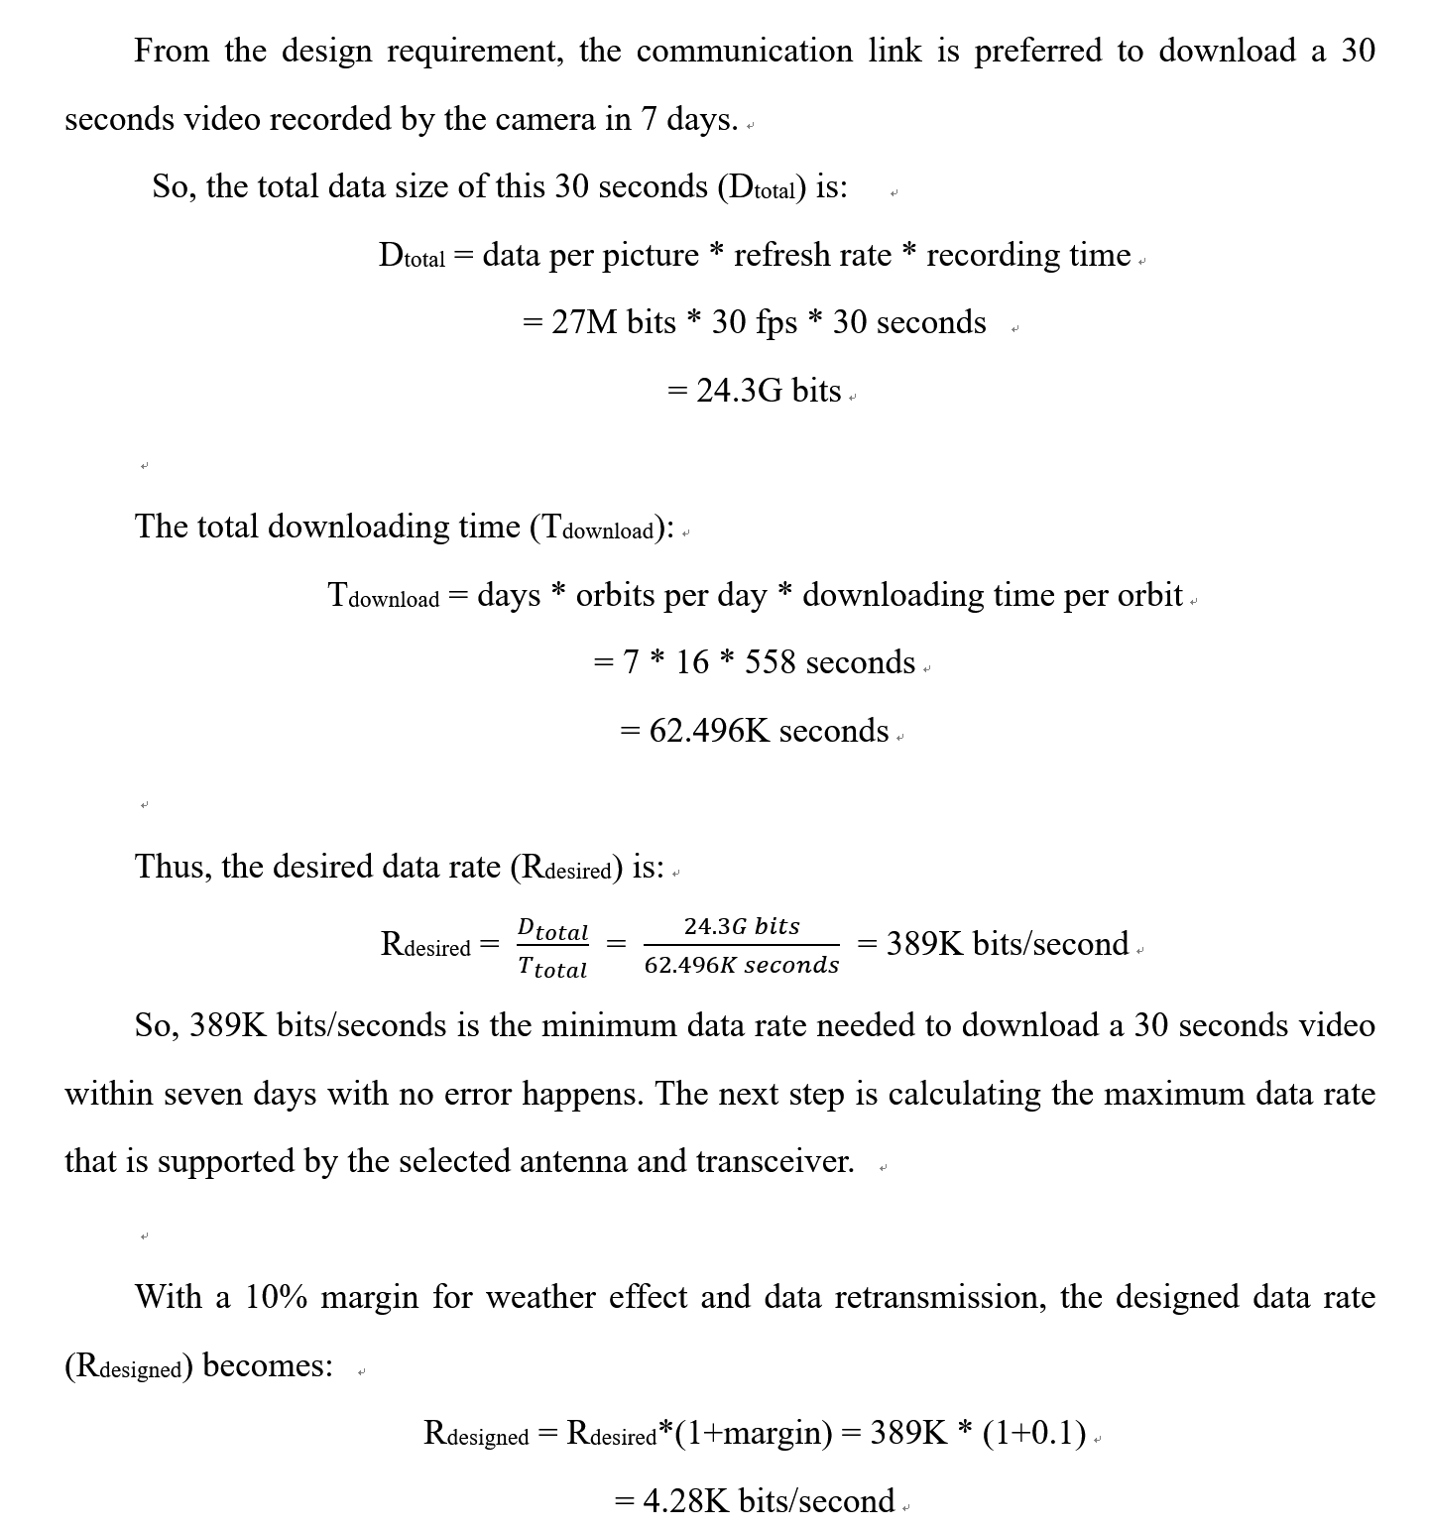

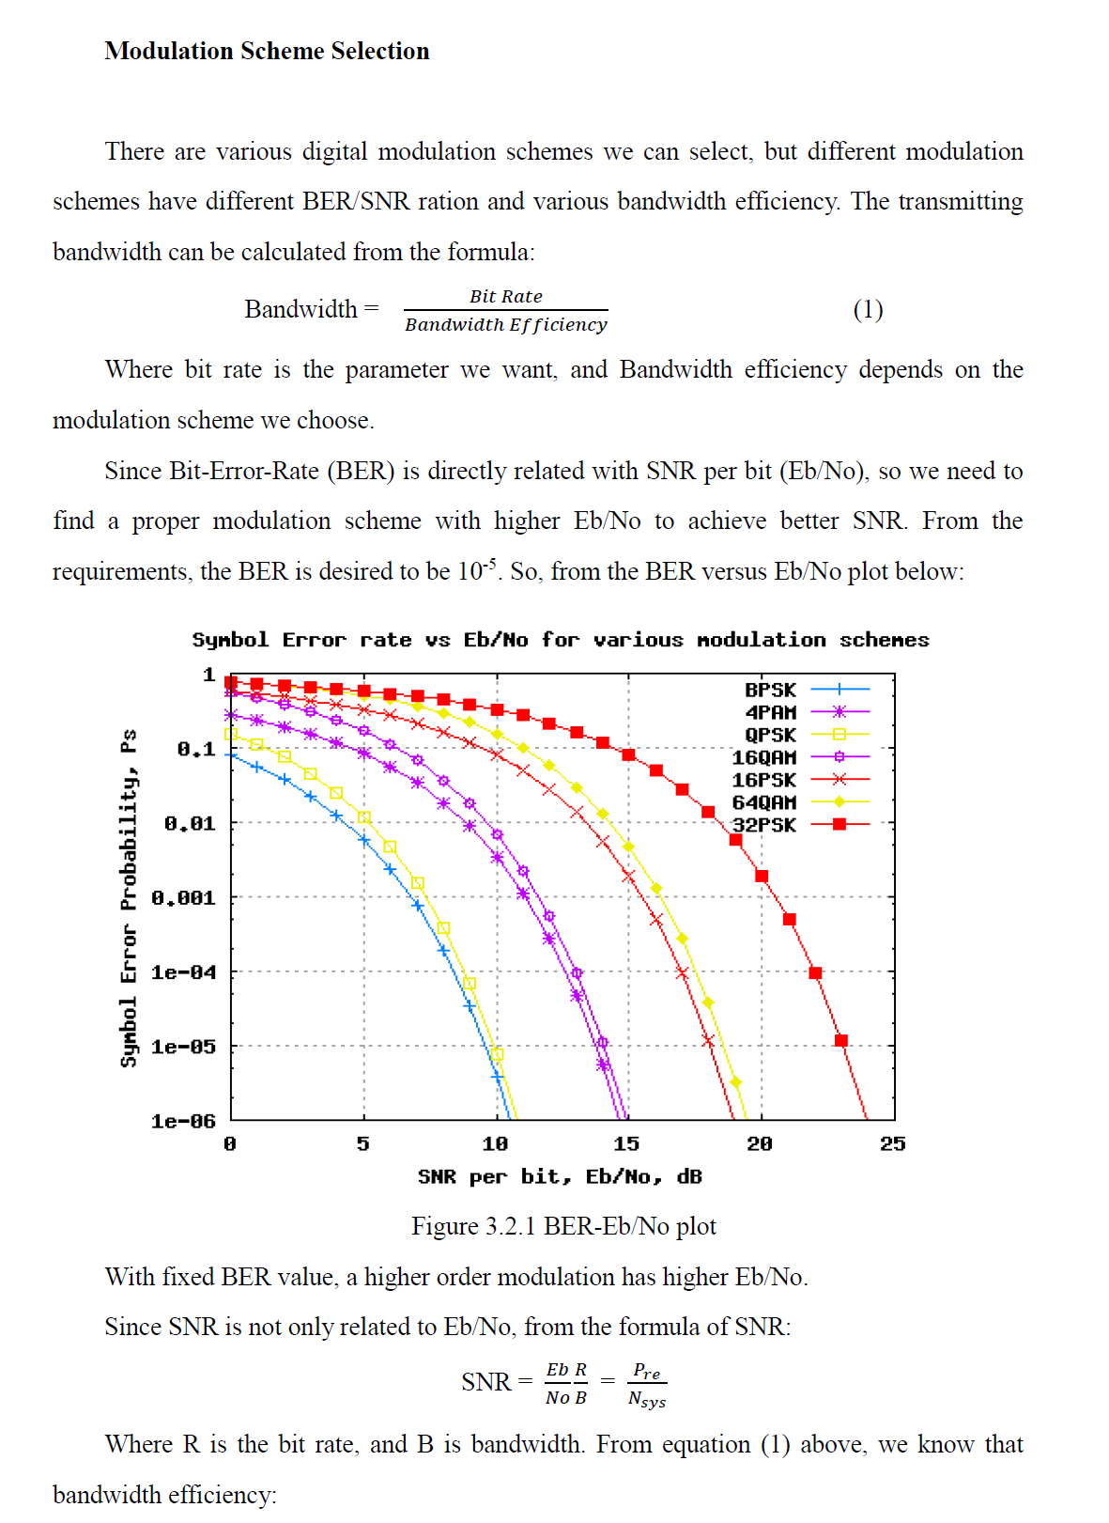

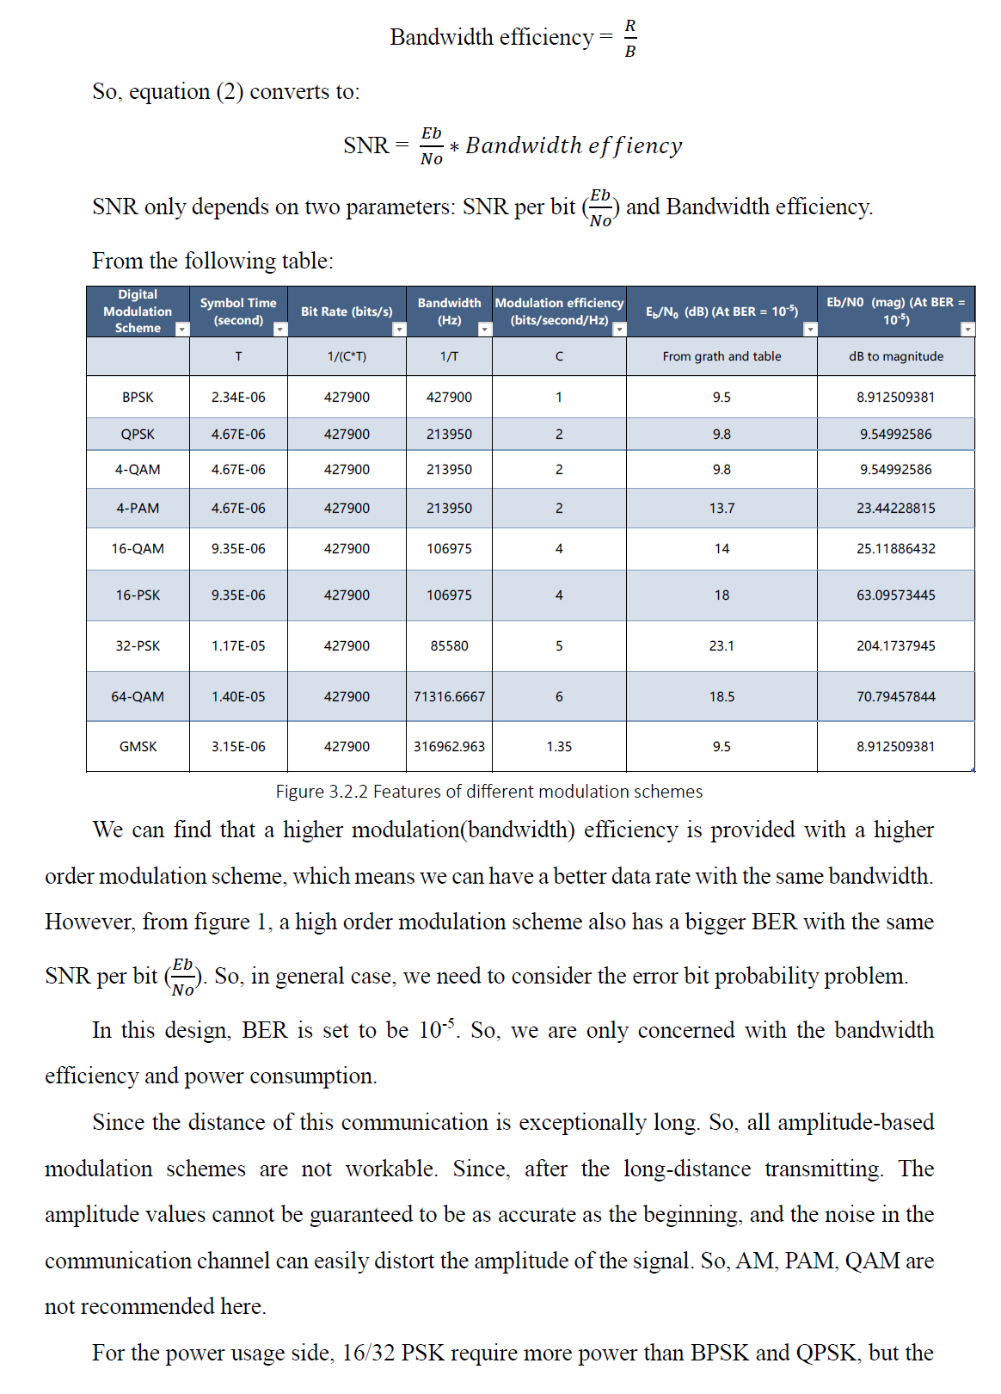

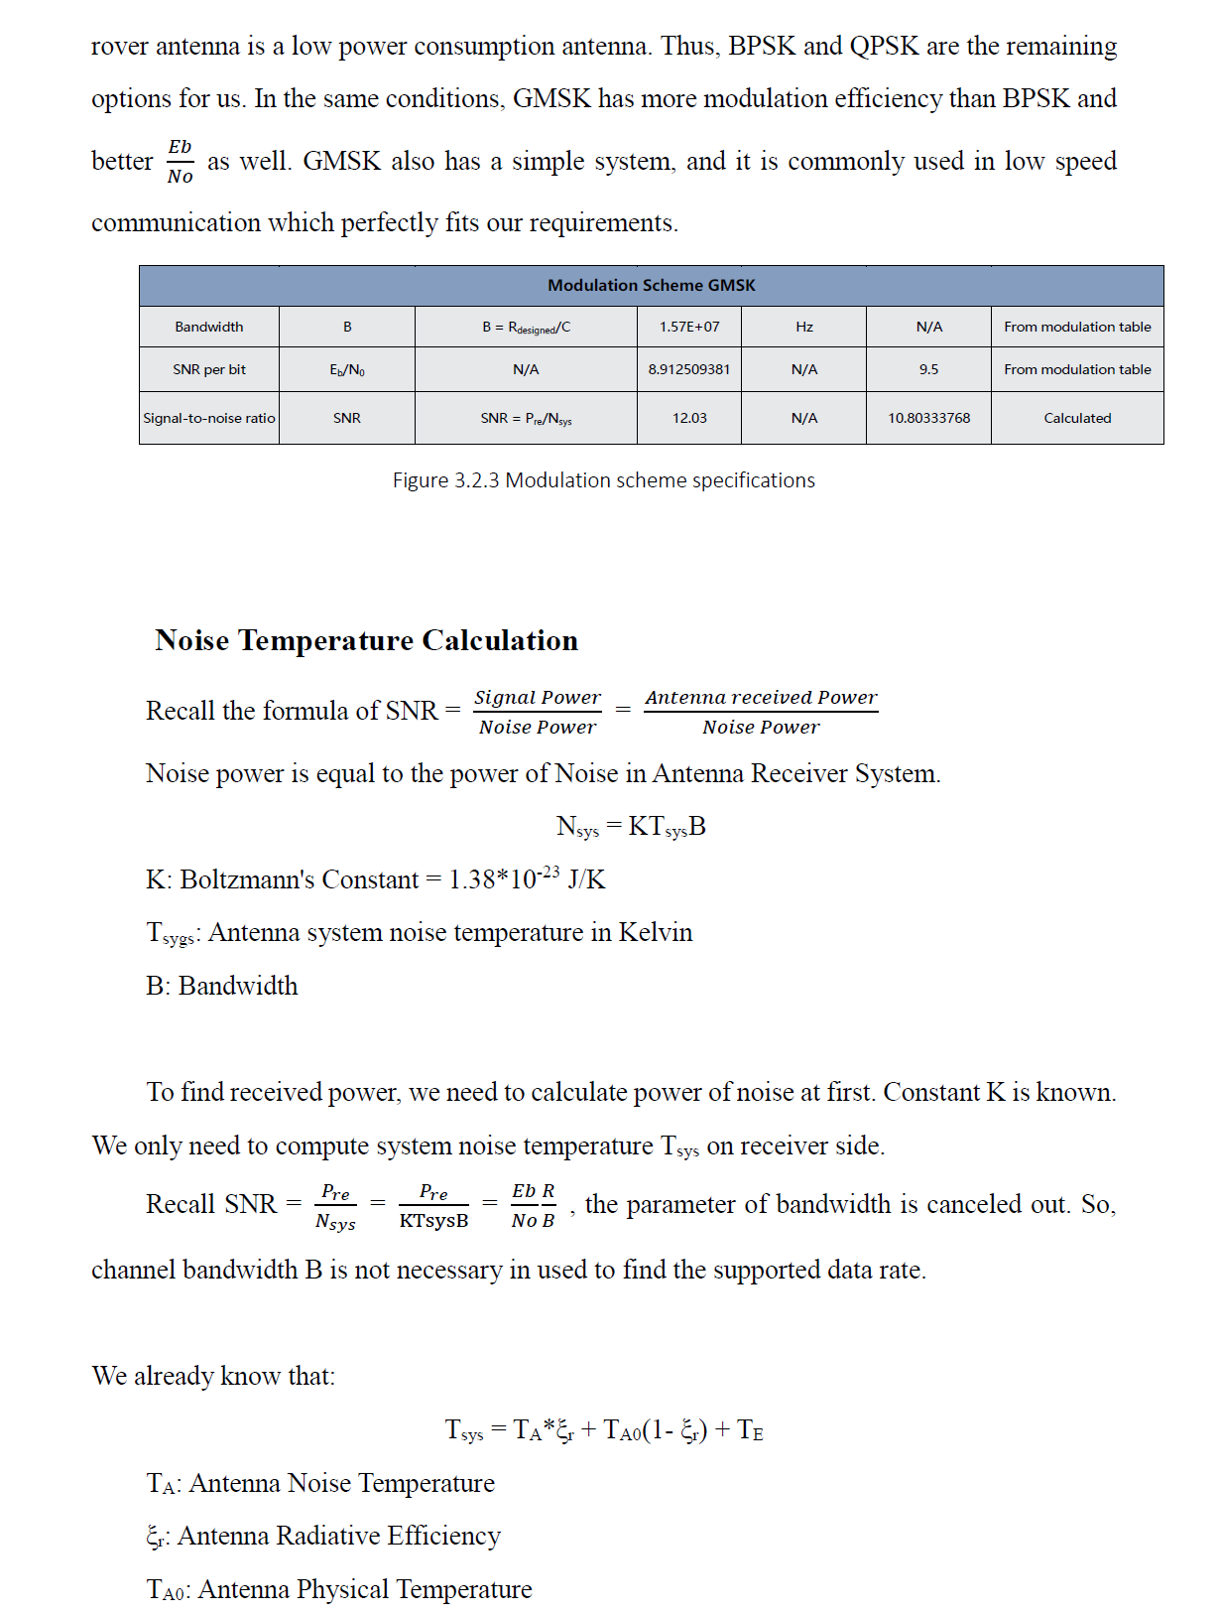

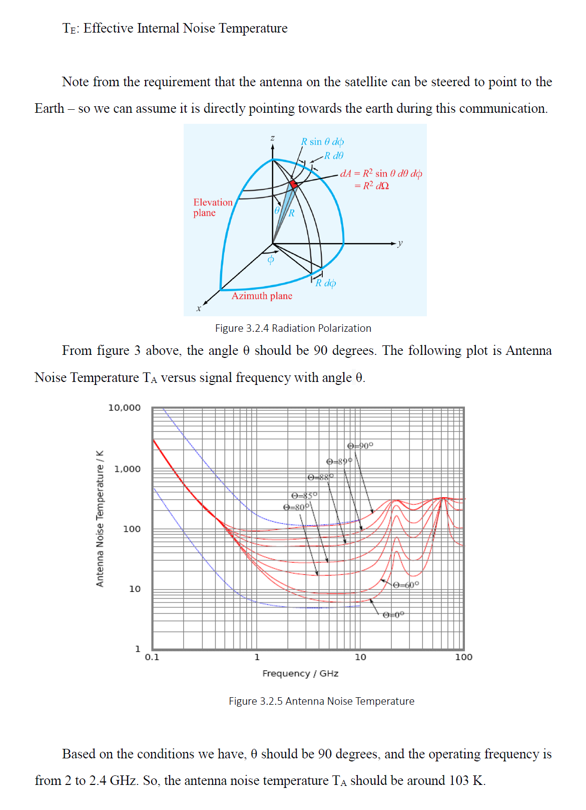

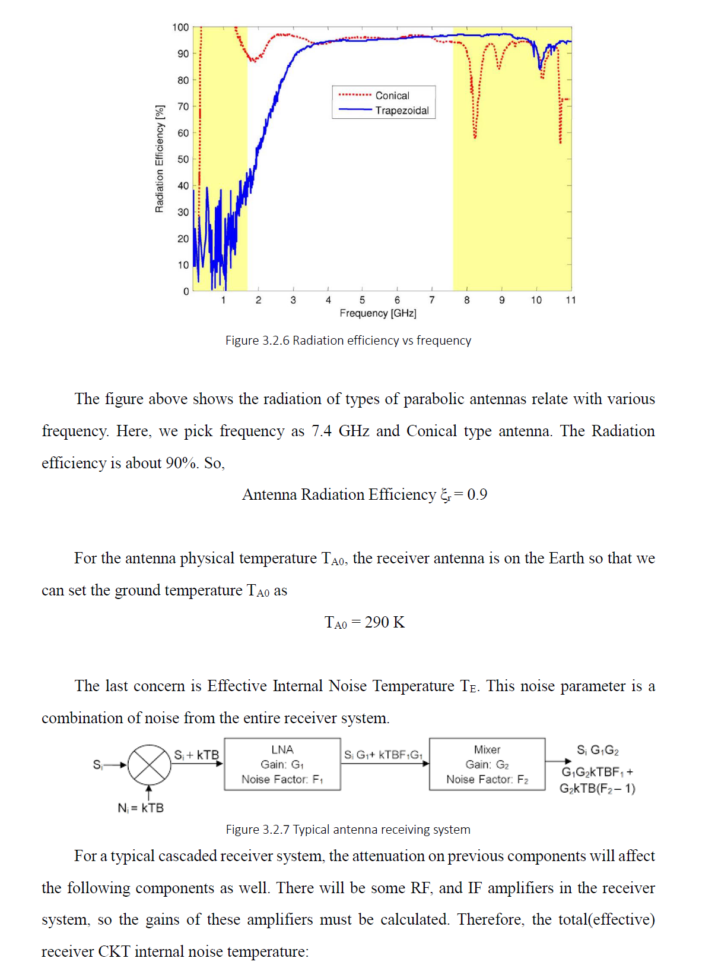

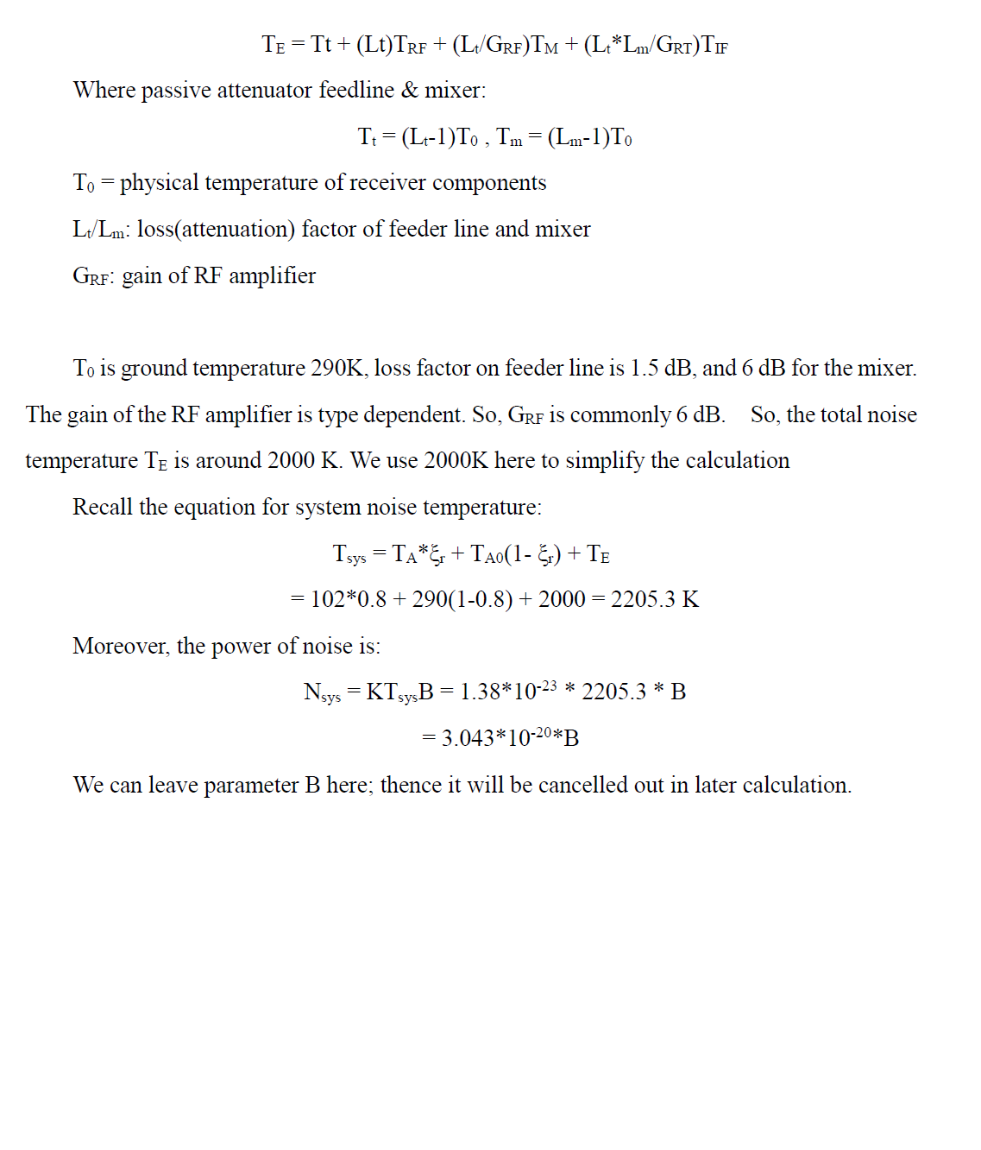

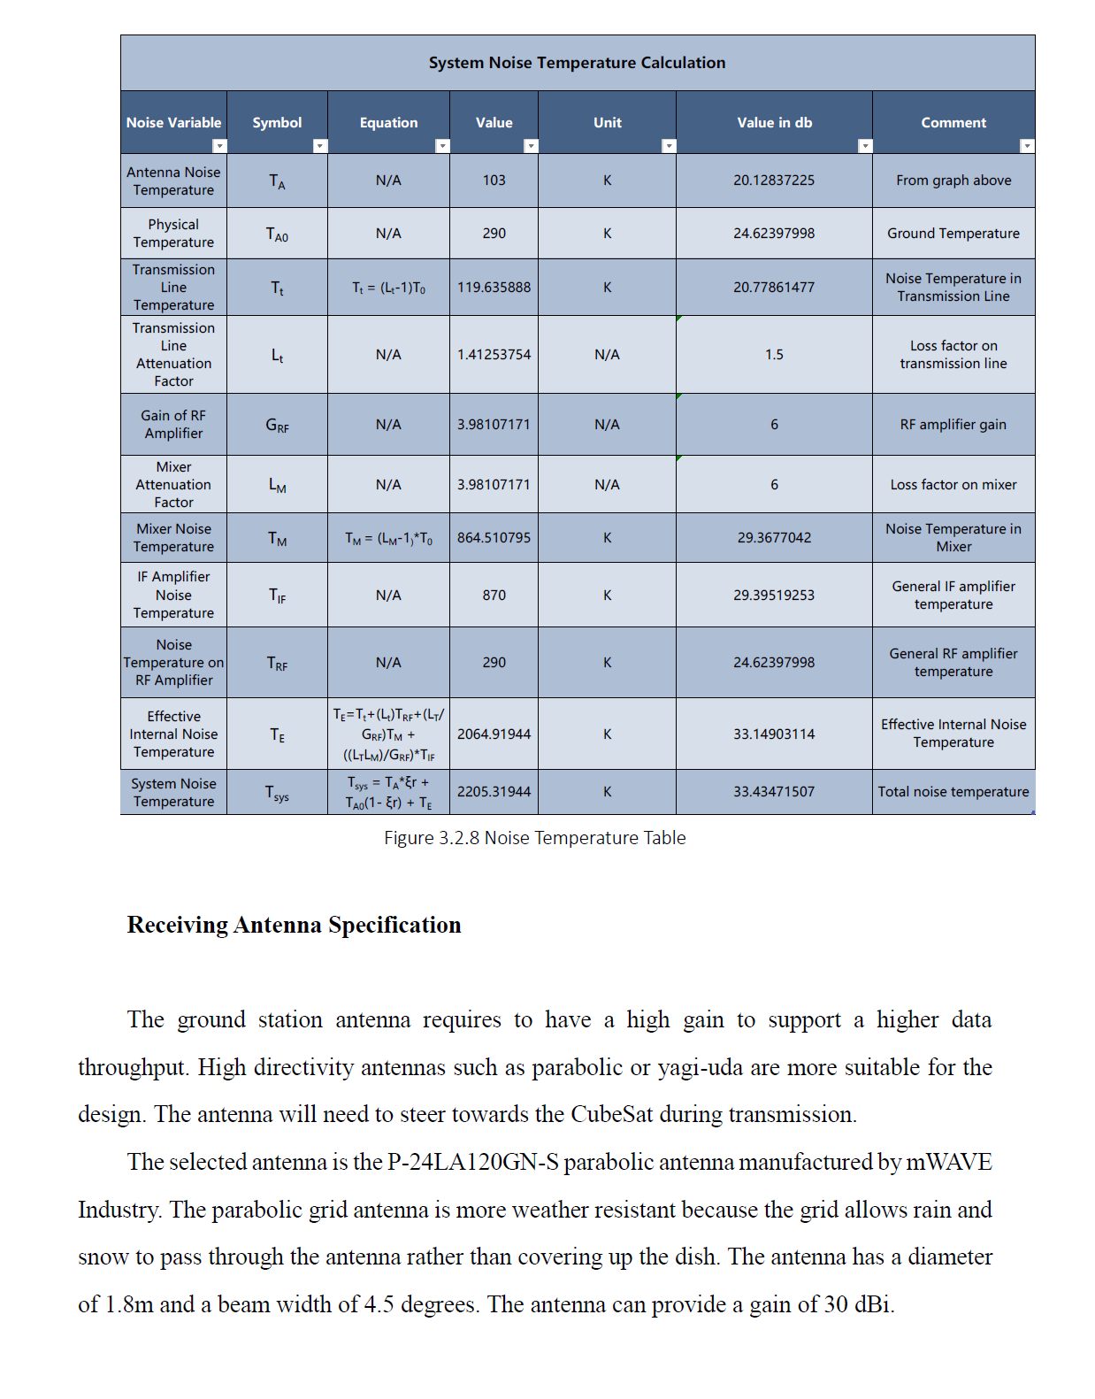

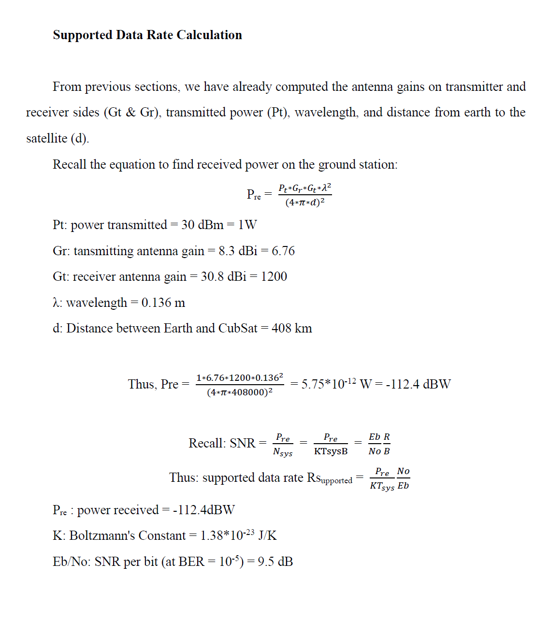

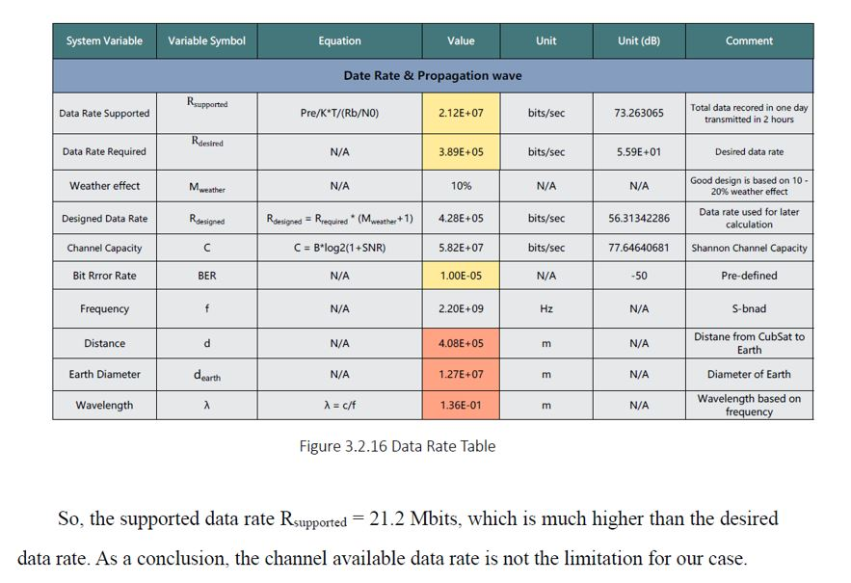

**Risk Assessment on High Directivity Antennas**

Committing to a higher directional antenna has several drawbacks. The antenna needs to be pointing to specific angle to establish successful transmission, the antenna will not receive stable signal if it is not pointed within the limited angle. There is a much higher demand on the ADCS (Attitude Determination and Control System) subsystem. Passive ADCS equipment will not be sufficient because it only provides detumbling. More technical equipment with precise pointing mechanism shall be employed. Active ADCS equipment such as magnetorquer or reaction wheel needs to be installed.

The additional ADCS devices will impact the mass budget by adding more mass and shifting the original centre of mass. Some ADCS techniques such as gravity gradient may not be applicable after the change in mass budget.

The ADCS devices will also need to operate to set the CubeSat into appropriate position before the antenna is switch into transmission mode. This additional step will require extra power, so it will also impact the power budget by consuming more power from the battery.

4**. Prototype Validation Plan**

## **4.1 Prototype Concept**

Our team is working on the first missions in a 3-year project, so, the prototype we need is based on mathematical models and computer simulations. At the end of this term a complete mathematical model should be built; thus, the link budget can be computed dynamically with variable parameters from antennas, transceivers and receiver systems. The desired math prototype should include all effects from channel noise, CubeSat direction and transmitting time duration.

On the simulation side, the simulation result should show the selected modulation scheme can reach the data rate we required with an acceptable BER range. The computer simulation can be achieved by using Arduino hardwire devices. The encoding and decoding parts can be implemented by Arduino as well.

## **4.2 Budget/Parts list details**

# The CubeSat Project at Western is proposed to be three-year in length starting this year, it is currently at the very early stage of the mission. Within the one-year duration of capstone, the project will only be working on Phase A, constructing the preliminary design. It is unlikely that any physical hardware will be implemented in the capstone project because CubeSat components typically cost thousands. Most of the work done will be only computer simulations.

# MATLAB will be used to model CubeSat’s communication scheme, with the aid of the Communication Toolbox in Simulink. The software is available for free with a Western student account. In Simulink, the communication link can be modelled with block diagrams using various modulation, encoder and filter blocks. The link performance can be tested using BER and SNR graph and spectrum analyzer.

# In addition, it is prospected to use Arduino to implement a RF transceiver module. Having a physical prototype is useful to perform some real testing on transmitting and receiving data with the integration of using a microcontroller. The cost of Arduino, breadboard, and RF transceiver and microcontroller are approximately $50 in total, which can be all purchased online.

**On Board S-Band Patch Antenna Selection**

The following key features were considered when selecting a preliminary Patch antenna:

· center frequency gain

· beam width

· mass

Center frequency gain was the most important consideration since it contributes to the power at the receiving antenna, which effects the Signal to Noise numerator of our system and thus, directly effects the data rate. Beam width and mass were treated more as limitations, since we were given maximum pointing requirements and a mass budget from respective subsystems. Table 1: Summary of S-Band patch antennas key features

|  |  |  |  |  |
| --- | --- | --- | --- | --- |
| Company | Center frequency gain (dBi) | Beam Width (deg) | Mass (g) | Website |
| EnduroSat | 8.3 | 71 | 64 | https://www.endurosat.com/products/cubesat-s-band-patch-antenna/ |
| NanoAvionics | 6 | 40 | 49 | https://n-avionics.com/subsystems/cubesat-s-band-patch-antenna/ |
| CubeSatShop | 6 | 85 | 72 | https://www.cubesatshop.com/product/s-band-patch-antenna-rhcp-hispico/ |

The selected Patch antenna is the Cubesat S-band Patch Antenna made by EnduroSat. This antenna was chosen over other candidates mainly for its superior center frequency gain. With this antenna selected, the total mass of the transceiver and antenna comes out to 254 g. When comparing total mass to our allotted mass budget (5% of 3.6g=180g), It appears this selection oversteps our budget. However, after discussion with a member of the structural team, it has been decided that this mass overshoot is justified, since the currently selected parts in the model puts the mass of the CubeSat well below 3.6 kg.

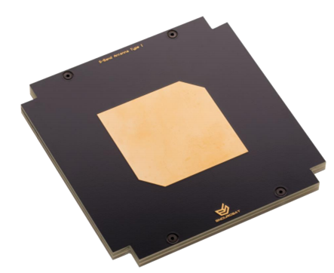

Figure 1: Top Side

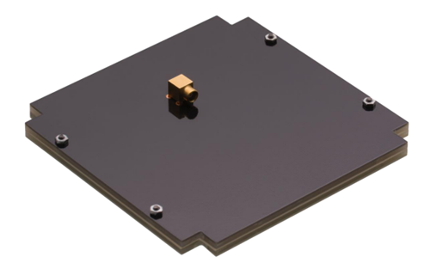

Figure 2: Bottom Side

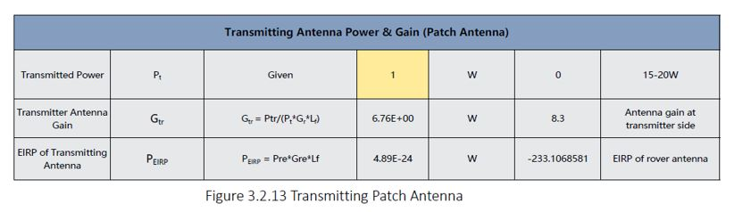

**Ground Station Antenna Selection**

The ground station antenna requires to have a high gain to support a higher data throughput. High directivity antennas such as parabolic or yagi-uda are more suitable for the design. Antenna will need to steer towards the CubeSat during transmission. With the CubeSat in ISS orbit 408Km from earth, the minimum required beam width is 2.6 $°$. The only given restriction for ground antenna selection is its physical size, it is required to be smaller than 2m.

The selected antenna is the P-24LA120GN-S parabolic antenna manufactured by mWAVE Industry. The parabolic grid antenna is more weather resistant because the grid allows rain and snow to pass through the antenna rather than covering up the dish. The antenna has a diameter of 1.8m and a beam width of 4.5 degrees. The antenna can provide a gain of 30 dBi.

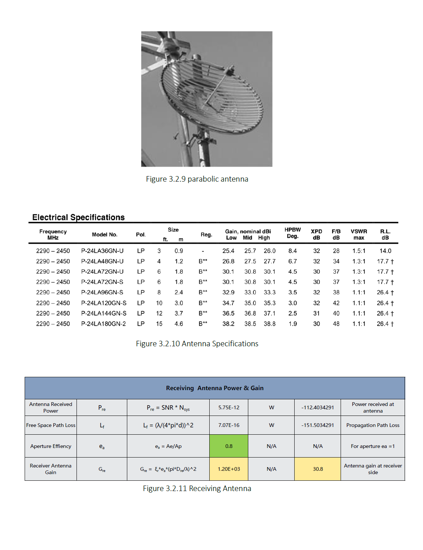

**Transceiver Selection**

Given the design choice that minimum number of boards is used for each subsystem, a single transceiver is required to provide both transmitting and receiving abilities. However, many manufacturers only supply transmitters instead of transceivers for S-Band operation. It results very limited options for off-the-self S-Band CubeSat transceiver. The following chart lists the transceiver models that have been viewed for selection.

|  |  |  |  |  |  |  |  |  |  |  |
| --- | --- | --- | --- | --- | --- | --- | --- | --- | --- | --- |
| brand | data rate (kbps) | | transmitted power | supply power (V) | power consumption | | frequency (GHz) | mass (g) |  |  |
|  | Tx | Tx |  |  | Rx | Tx |  |  |  |
| Endurosat | 20000 |  | 2W | 5,12 | 9 |  | 2.2-2.29 |  | transmitter | https://www.endurosat.com/products/cubesat-s-band-transmitter/ |
| Nano Avionics | 100 - 500 | 100 | 20 to 30 dBm | 5-40 | 0.65 | 6.5 (tx+rx) | 2.2-2.30 | 191 | transceiver | https://n-avionics.com/subsystems/s-band-transceiver/ |
| Satlab | 128 - 512 | 128 | 20 to 30 dBm | 5-41 | 0.65 | 5 | 2.2-2.31 | 190 | transceiver | https://www.satlab.com/resources/SLDS-SRS3-1.1.pdf |
| IQ Wireless | 600-40000 |  | 27 dBm | 7 - 18W | 3-4.5 | 8 - 12 W | 2.2-2.32 | 420 | transceiver | http://www.iq-wireless.com/images/pdf/SLINK-Datasheet.pdf |
| ISIS | 3400 |  | 27-33 dBm | 6-20V | 2 | 9 | 2.2-2.30 | <300 | transmitter | https://www.isispace.nl/product/isis-txs-s-band-transmitter/ |

The preliminary power budget given from the power subsystem is 5 to 7W, with this restricted amount of power, it eliminates options for using high-power high-performance models.

The selected transceiver is the SRS-3 full-duplex low-power s-band transceiver made by Satlab. Although it only supports a maximum transmission rate of 512kpbs, it consumes significantly lower power. It operated in the s-band frequency range 2.2 – 2.32 GHz, and it has integrated transmit and receive filter, low noise amplifier (LNA) and power amplimer.

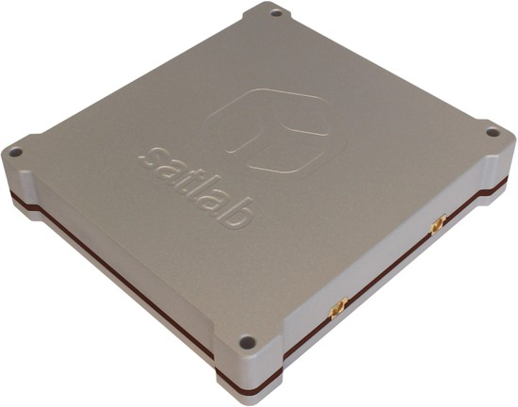

Figure 1 Satlab SRS-3 transceiver

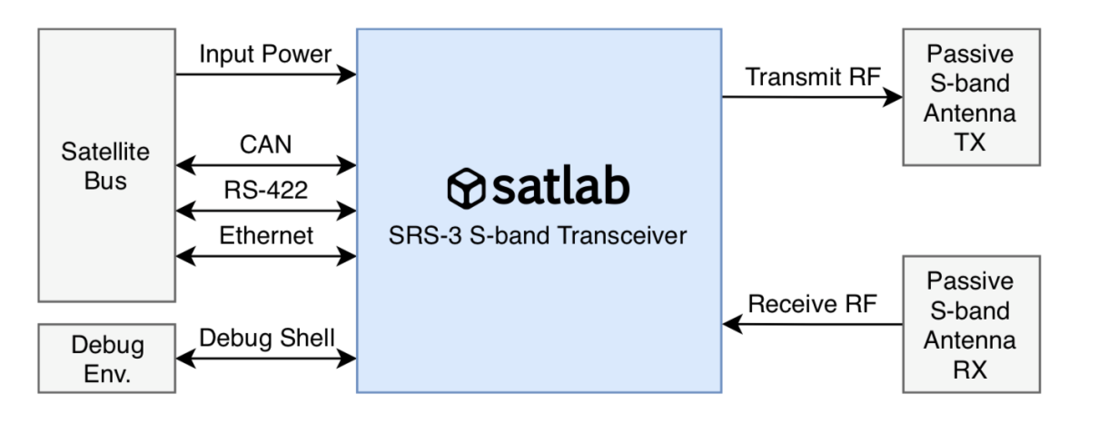

Figure 2 transceiver interface overview

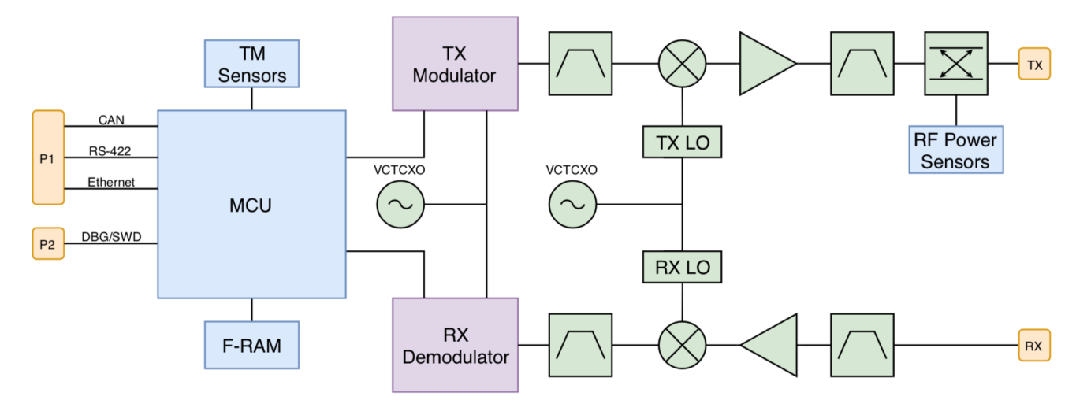

Figure 3 transceiver hardware block diagram

The following chart lists some of the key parameters of the transceiver.

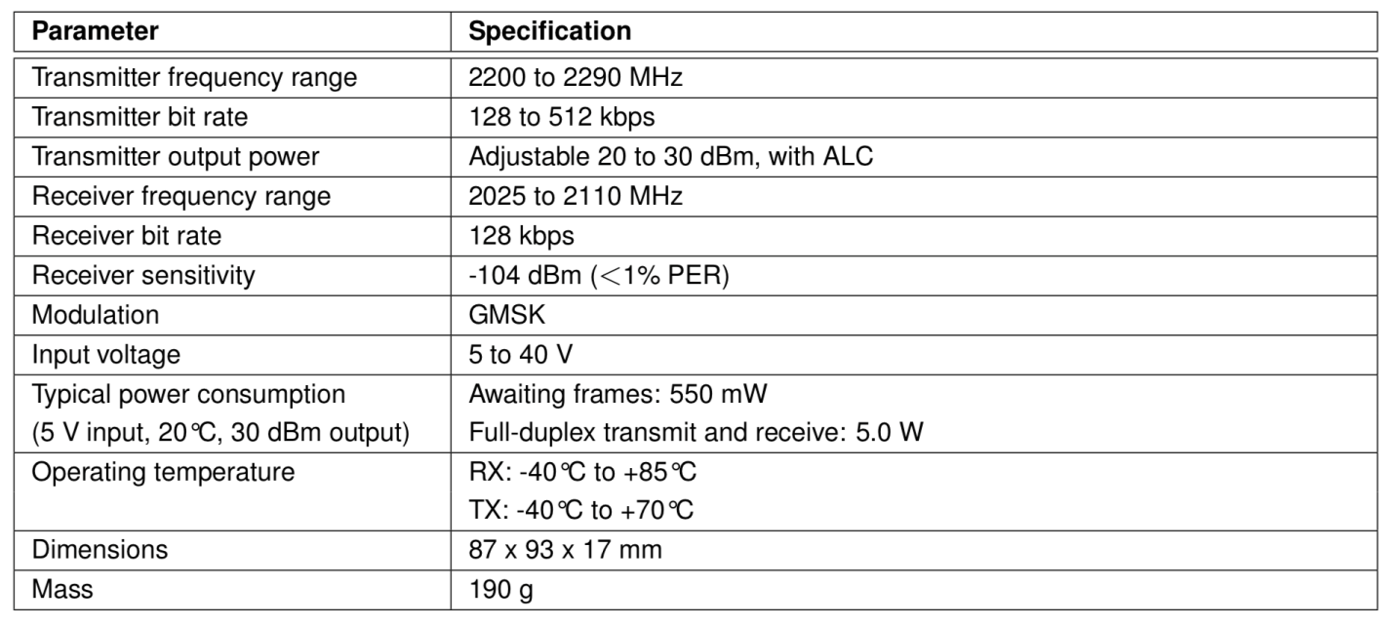

Figure 4 transceiver key parameters

# **5. Team member contribution**

Zhengxing Liu:

**Antenna concept generation**

Different types of antennas were proposed, which includes using a single patch antenna or antenna arrays with four dipole antennas.

**Antenna models and radiation pattern models in MATLAB**

Antenna models were built for each of the proposed antenna concepts. Based on the models, 3D radiation patterns were simulated using Antenna Toolbox in MATLAB.

**Concept selection, trade-off study and risk assessment**

Radiation patterns, mission objectives and requirements were used to evaluate the antennas. Risk assessment was conducted for the selected patch antenna.

**CubeSat antenna and ground station antenna selection**

Commercial off-the-shelf models were selected for purchase. The selection process was based on mission requirements including assigned frequency range and desired data rate.

Jiayang Song:

**Link budget modelling**

Link budget calculation has different components including transmitter side, receiver side, communication channel, antenna effect and modulation scheme.

**Data size and data rate evaluation**

Based on the data recorded by the camera on CubeSat. A desired data rate was calculated based on a required downloading time duration.

**Typical receiver system modelling and system thermal noise calculation**

A sample receiver framework was established to evaluate the effect system thermal noise in the entire data link. A general noise temperature was computed and used in the power and data rate calculation.

**Selected CubeSat antenna and ground station antenna evaluation**

Based on the specifications of selected antenna, the power and antenna gain parameters had been defined. A communication channel was built, and the channel capacity satisfied the time requirements of downloading. An excel table was created to show the entire calculation process dynamically.

Rajja Singh

**Problem Statement**

Defined the problem statement.

**Project Objectives**

Defined project objectives and compiled project constraints through discussions with the electrical power and structural teams.

**Data Rate Calculation**

Found a preliminary data rate to see how much of the data recorded on the CubeSat could be transferred using S Band frequencies during the transfer window.

**CubeSat Antenna Selection**

Based on project objectives and constraints, an off the shelf transceiver was selected after comparing several transmitters, receivers, and transceivers.

Daniel Rea

**Detailed Literature Review**

Read up on benefits to S-Band communication, and required components for a CubeSat communication system. Read up on the key considerations of any CubeSat communication subsystem including spectral and power efficiency.

**Performed modulation Trade-off Study**

read up on performance of low, moderate and high order modulation schemes, and compared their performance in terms of power and spectral efficiency. Analysed Bit error curves to rule out most schemes.

**Modeled Basic modulation schemes in MATLAB**

modulation schemes of BPSK and PAM were coded and bit error curves were plotted to produce results equivalent to theoretical. Gained hands on experience in altering power in a signal to observe its effect on constellation diagram

**Transceiver concept generation**

Considered multiple transceiver options. Systematically determined best option based on other subsystem limitations, and project objective. Careful consideration on central operating frequency and modulation scheme was taken for link budget calculations.

# 

# 

# **6. References**

|  |  |
| --- | --- |
| [1] | E. Kulu, "NanoSatellite and CUbeSat Database," 28 December 2018. [Online]. Available: https://www.nanosats.eu/. [Accessed 21 October 2018]. |
| [2] | S. E. Palo, "High Rate Communication system for CubeSats," Pheonix,AZ,USA, 2015. |
| [3] | W. Gao, Energy and Bandwidth Efficient Wirless Transmissions, Switzerland: Springer International Publishing, 2017. |
| [4] | J. A. Bryan Klofas, "A Survey of CubeSat Communication Systems," California Polytechnic State University, California, 2008. |
| [5] | N. Islam, "Energy Efficiency in Wireless Communication," RMIT University, Bangladesh, 2017. |
| [6] | V. F. M. H. Arthur Gaysin, "Survey of modulation and coding schemes for application in CubeSat systems," in *2017 Systems of Signal Synchronization, Generating and Processing in Telecommunications (SINKHROINFO)*, Kazan, Russia, 2017. |
| [7] | C. B. Crail, "Ranking CubeSat Communication Systems Using a Value-centric Framework," Massachusetts Institute of Technology, Texas, 2007. |
| [8] | J. A. Bryan Klofas, "A Survey of CubeSat Communication Systems," California Polytechnic State University, California, 2008. |

# 

# **7. Gantt charts**

3 year long term events were omitted since they do not affect our work. We only included what we plan to do throughout second semester.

